Print Report Data

Author: $Author

Publisher: $Publisher

Date: $date

This sample template will print user report data.

This sample is a practical demonstration of Velocity Template Language (VTL) usage of variable properties and the report data

Report variables are defined in Variable button on "Select a report data" step. Sees Figure 1 Report variable dialog.

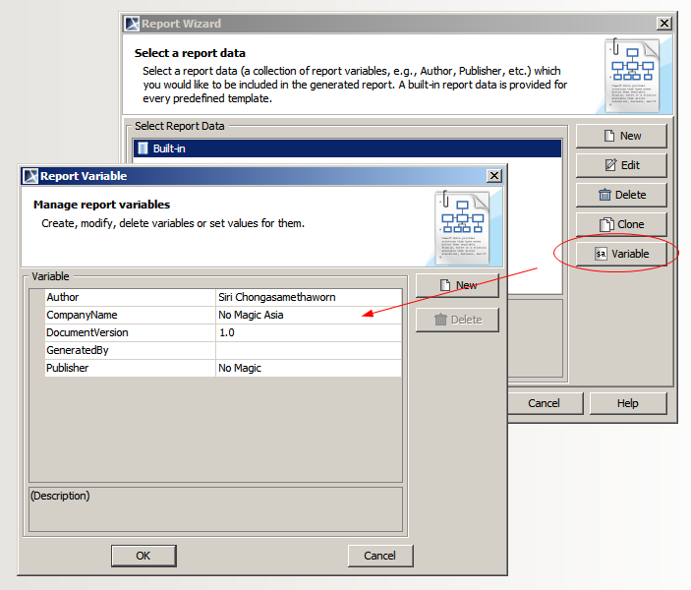
Figure 1 Report variable dialog

Author: $Author
Company Name: $CompanyName
Generated By: $GeneratedBy
Publisher: $Publisher

Report variable can be nested as hierarchy. Sees Figure 2 Variable dialog show nested report variable

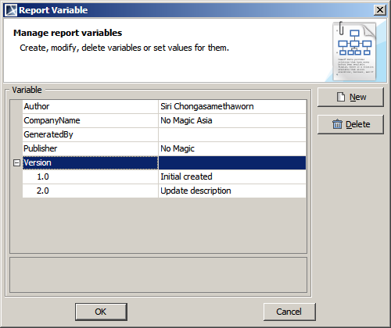
Figure 2 Variable dialog show nested report variable
Type any the following to print a child variable
- \$var.get(1): to get a child value by index.
- \$var.child: to get a child value by referencing its name (in this case “child”)
- \$var.get(“child”): to get a child value by name comparison.
- \$var.firstChild: to get the first child of variable
- \$var.lastChild: to get the last child of variable

Document has $Version.size() versions. The latest version is $Version.lastChild.name

Version | Description
#forrow ($ver in $Version)  $ver.name | $ver.value#endrow

